**Chemical Degradation**

**The solubility and other physicochemical properties of the penicillins are affected by the nature of the acyl side chain and by the cations used to make salts of the acid.**

**Cations:-**

**The free acids are not suitable for oral or parenteral administration. Therefore, two types of salts are present:**

1. **Inorganic salts**

**The sodium and potassium salts of most penicillins, however, are soluble in water and readily absorbed orally or parenterally.**

1. **Organic salts**

**Such as benzathine and procaine, have limited water solubility and are, therefore, useful as depot forms to provide effective blood levels over a long period in the treatment of chronic infections.**

**Penicillin hydrolysis:-**

**a- Acidic medium**

**In strongly acidic solutions (pH <3), penicillin undergoes a complex series of reactions leading to various inactive degradation products.**



**b- Basic medium**

**Penicilloic acid, the major product formed under weakly acidic to alkaline (as well as enzymatic) hydrolytic conditions.**



**Acyl side chain:-**

**Substitution of an electron-withdrowing group( -NH2, -Cl, hetroaromatic ring, phenoxy…etc) in the R position of benzylpenicillin markedly stabilizes the penicillin to acid-catalyzed hydrolysis. Thus, phenoxymethylpenicillin, aminobenzylpenicillin, are significantly more stable than benzylpenicillin in acid solutions. How?**



**Allergy to Penicillins**

**Allergic reactions to various penicillins, ranging in severity from a variety of skin and mucous membrane rashes to drug fever and anaphylaxis, constitute the major problem associated with the use of this class of antibiotics.**

**Bacterial Resistance**

**Mechanisms:**

1. **The most important biochemical mechanism of penicillin resistance is the bacterial elaboration of enzymes that inactivate penicillins. Such enzymes, which have been given the nonspecific name penicillinases, are of two general types:-**
2. **β-lactamases.**
3. **Acylases.**

**The more important of these are the β-lactamases, enzymes that catalyze the hydrolytic opening of the β-lactam ring of penicillins to produce inactive penicilloic acids.**

**Acylases can hydrolyze the acylamino side chain of penicillins, but their possible role in bacterial resistance has not been well defined.**

***β-lactamases***

*.*

 ***Acylases*** 

1. **Another important resistance mechanism, especially in Gram-negative bacteria, is decreased permeability to penicillins. The cell envelope in most Gram-negative bacteria is more complex than in Gram-positive bacteria. It contains an outer membrane not present in Gram-positive bacteria, which creates a physical barrier to the penetration of antibiotics, especially those that are hydrophobic. Small hydrophilic molecules, however, can traverse the outer membrane through pores formed by proteins called porins.** **Alteration of the number or nature of porins in the cell envelope also could be an important mechanism of antibiotic resistance.**
2. **Bacterial resistance can result from changes in the affinity of PBPs for penicillins.**

**Natural penicillins:**

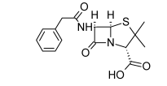**Penicillin G (benzylpenicillin)**

* **It is made as water soluble salts of potassium, sodium, and calcium.**
* **These salts of penicillin are inactivated by the gastric juice and are not effective when administered orally unless antacids is added.**

** Penicillin G Procaine :**

* **It is an organic amine salt of penicillin G.**
* **Low water solubility.**
* **Administered IM and serve as depot forms.**



**Penicillin G Benzathine:**

* **It is an organic amine salt of penicillin G.**
* **Very insoluble in water.**
* **Administered IM and serve as depot forms.**

**Penicillin V**

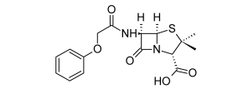

* **It resistance to hydrolysis by gastric juice( given orally).**

**Penicillinase-Resistant Penicillins**

* **Increasing the steric hindrance at the α-carbon of the acyl group increased resistance to staphylococcal β-lactamase.**
* **The α-acyl carbon could be part of an aromatic (e.g., phenyl or naphthyl) or heteroaromatic (e.g., 4-isoxazoyl) system.**
* **Substitutions at the ortho positions of a phenyl ring (e.g., 2,6-dimethoxy [methicillin]) or the 2-position of a 1-naphthyl system (e.g., 2-ethoxyl [nafcillin]) increase the steric hindrance of the acyl group and confer more β-lactamase resistance than shown by the unsubstituted compounds or those substituted at positions more distant from the α-carbon.**
* **Bulkier substituents are required to confer effective β-lactamase resistance among five-membered–ring heterocyclic derivatives. Thus, members of the 4-isoxazoyl penicillin family (e.g., oxacillin, cloxacillin, and dicloxacillin) require both the 3-aryl and 5-methyl substituents for effectiveness against β-lactamase–producing S. aureus.**
* **All of the clinically available penicillinase-resistant penicillins are significantly less active than either penicillin G or penicillin V against most non–*β*-lactamase-producing bacteria normally sensitive to the penicillins.**
* **The isoxazoyl penicillins, particularly those with an electronegative substituent in the 3-phenyl group (cloxacillin, dicloxacillin, and floxacillin), are also resistant to acid-catalyzed hydrolysis of the *β*-lactam, for the reasons described previously.**
* **Steric factors that confer *β*-lactamase resistance, however, do not necessarily also confer stability to acid. Accordingly, methicillin, which has electron-donating groups (by resonance) *ortho* to the carbonyl carbon, is even more labile to acid-catalyzed hydrolysis than is penicillin G because of the more rapid formation of the penicillenic acid derivative.**



**Methicillin Sodium**



* **The absence of the benzyl methylene group of penicillin G and the steric protection afforded by the 2- and 6-methoxy groups make this compound particularly resistant to enzymatic hydrolysis.**
* **Because of its toxicity (interstitial nephritis), it is not used clinically.**
* **Cannot be given orally( acid sensitive).**

**Nafcillin Sodium**



* **Like methicillin, nafcillin has substituents in positions ortho to the point of attachment of the aromatic ring to the carboxamide group of penicillin. No doubt, the ethoxy group and the second ring of the naphthalene group play steric roles in stabilizing nafcillin against penicillinase.**
* **Unlike methicillin, nafcillin is stable enough in acid to permit its use by oral administration.**

**Oxacillin Sodium**



* **Apparently, the steric effects of the 3-phenyl and 5-methyl groups of the isoxazolyl ring prevent the binding of this penicillin to the β-lactamase active site and, thereby, protect the lactam ring from degradation in much the same way as has been suggested for methicillin.**
* **It is also relatively resistant to acid hydrolysis and, therefore, may be administered orally with good effect.**

**Cloxacillin Sodium**



* **The chlorine atom ortho to the position of attachment of the phenyl ring to the isoxazole ring enhances the activity of cloxacillin sodium over that of oxacillin, not by increasing its intrinsic antibacterial activity but by enhancing its oral absorption, leading to higher plasma levels. In almost all other respects, it resembles oxacillin.**

**Extended-Spectrum Penicillins:**

**By introducing of hydrophilic group( NH2, OH, COOH, UREA) on the α-C.**

**Ampicillin and amoxicillin.**

* **Introducing an ionized or polar group into the α-position of the side chain benzyl carbon atom of penicillin G confers activity against Gram-negative strains like: *Escherichia, Klebsiella, Haemophilus, Salmonella* and *Shigella*.** **Furthermore, activity against Gram-positive species is largely retained.**
* **They penetrate Gram negative bacteria more readily than penicillin G, penicillin V, or methicillin. This selective penetration is believed to take place through the porin channels of the cell membrane.**
* **They are *β*-lactamase sensitive penicillins.**
* **They are acid stable.**
* **Orally administered amoxicillin possesses significant advantages over ampicillin, including:**

1. **More complete GI absorption,**
2. **Less diarrhea.**
3. **Little or no effect of food on absorption.**

** **

**Anantipseudomonal penicillin:**

* **They are α-acylureido–substituted penicillins.**
* **They exhibit greater activity against certain Gram-negative bacilli (*P. aeruginosa)*.**
* **Facile penetration through the cell envelope of these particular bacterial species is the most likely explanation for the greater potency.**
* **The acylureidopenicillins, unlike ampicillin, are unstable under acidic conditions; therefore, they are not available for oral administration.**
* **They are inactivated by Pencillinase.**
* **Example: piperacillin.**

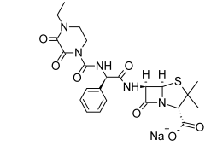

**β-Lactamase inhibitors**

**Mechanism: the mechanism of β-lactamase inhibitor is called mechanism based inhibitors, it involve:**

**An acyl- β-lactamaze enzyme intermediate is formed by reaction of the β-lactam with an active-site serine hydroxyl group of the enzyme.**

1. **For normal substrates, the acyl-enzyme intermediate readily undergoes hydrolysis, destroying the substrate and freeing the enzyme to attack more substrate.**
2. **The acyl-enzyme intermediate formed when a mechanism-based inhibitor is attacked by the enzyme is diverted by tautomerism to a more stable imine form that hydrolyzes more slowly to eventually free the enzyme (transient inhibition).**

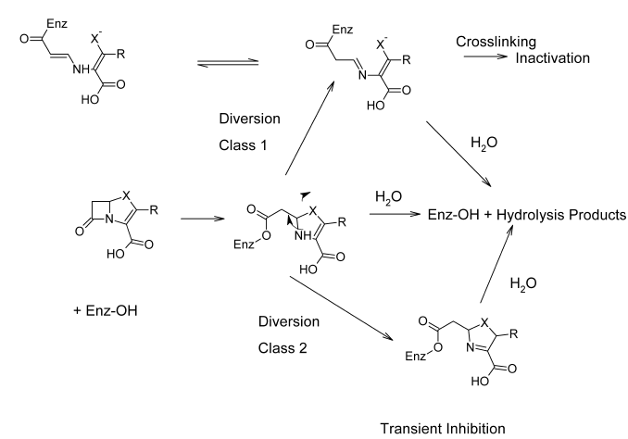

1. **Clavulanate Potassium**

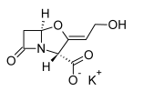

* **It exhibits very weak antibacterial activity.**
* **Combinations of amoxicillin and the potassium salt of clavulanic acid are available (Augmentin) in various fixed-dose intended for the treatment of skin, respiratory, ear, and urinary tract infections caused by β-lactamase–producing bacterial strains.**

1. **Sulbactam: structure and uses?**
2. **Tazobactam: structure and uses?**
3. **Carbapenems**
4. **Imipenem–Cilastatin**

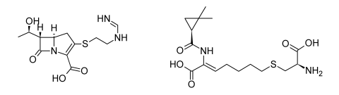

* **Imipenem retains the extraordinary broad-spectrum antibacterial properties, but susceptibility to hydrolytic inactivation by renal dehydropeptidase-I (DHP-I).**
* **It is very stable to most β-lactamase.**
* **Cilastatin is an inhibitor of DHP-I. The combination provides a chemically and enzymatically stable form.**
* **Not given orally(IV).**

1. **Meropenem**

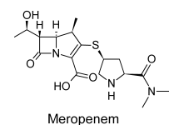

* **Meropenem exhibits greater potency against Gram-negative and anaerobic bacteria than does imipenem, but it is slightly less active against most Gram-positive species**
* **Meropenem is not hydrolyzed by DHP-I**
* **Like imipenem, meropenem is not active orally(IV).**